# Lab: Data Types and Variables

Problems for in-class lab for the ["JS Fundamentals " course @ SoftUni](https://softuni.bg/trainings/2343/js-fundamentals-may-2019).   
Submit your solutions in the SoftUni judge system at: [Data-Types-and-Variables-Lab](https://judge.softuni.bg/Contests/1242/Data-Types-and-Variables-Lab)

1. **Concatenate Names**

Write a **function** which receives two **names** as **string parameters** and a **delimiter**. Print the names **joined** by the delimiter.

**Examples**

|  |  |
| --- | --- |
| **Input** | **Output** |
| 'John',  'Smith',  '->' | John->Smith |
| 'Jan',  'White',  '<->' | Jan<->White |
| 'Linda',  'Terry',  '=>' | Linda=>Terry |

### Hints

Use [string interpolation](https://developer.mozilla.org/en-US/docs/Web/JavaScript/Reference/Template_literals).

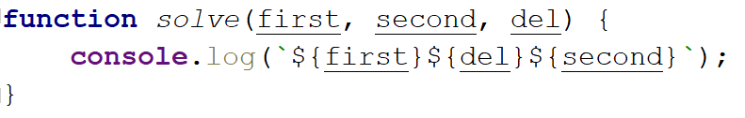

## Right Place

You will receive **3 parameters (string, char, string).**  
First string will be a word with a **missing char** replaced with a underscore '**_**'  
You have to **replace** the character with the missing part (**underscore**) from the first string and **compare** the result with the second string.

If they are equals you should print "**Matched**", otherwise print "**Not Matched**".

### Examples

|  |  |
| --- | --- |
| **Input** | **Output** |
| 'Str_ng', 'I', 'Strong' | Not Matched |
| 'Str_ng', 'i', 'String' | Matched |

### Hints

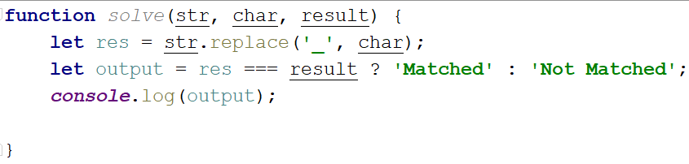

## Integer and Float

You will receive **3 numbers**. Your task is to find their **sum** and print it to the console with the addition   
" **- {type of the number (Integer or Float)}**":

### Examples

|  |  |
| --- | --- |
| **Input** | **Output** |
| 9, 100, 1.1 | 110.1 - Float |
| 100, 200, 303 | 603 - Integer |

### Hints

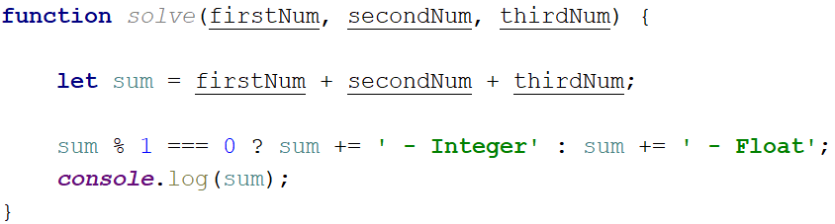

## Amazing Numbers

Write a **function** which as **input** will receive a **number**.

**Check** and print if it is **amazing** or **not** into the following format:

**" "**

An amazing number is one that includes the **digit 9** the sum of its digits.

Examples for amazing numbers are 1233 (1 + 2 + 3 + 3 = 9), 583472 (5 + 8 + 3 + 4 + 7 + 2 = 29)

### Examples

|  |  |
| --- | --- |
| **Input** | **Output** |
| 1233 | 1233 Amazing? True |
| 999 | 999 Amazing? False |

### Hints

Use **includes()**

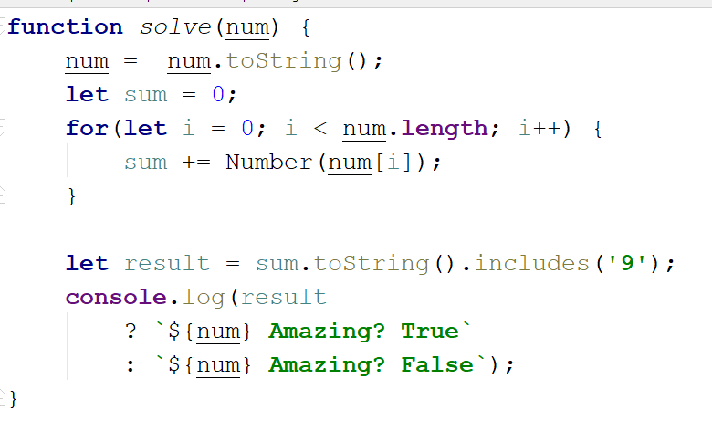

## Gramophone

Write a **function** which as **input** will receive **3 parameters (strings)**

* **First string** is the name of the **band**
* **Second string** is the name of the **album**
* **The third** is holding a **song** name from the album

You have to find out how many **times** the plate will **rotate** the given song from the album.

The plate makes a full rotation every **2.5** seconds.

The song **duration in seconds** is calculate by the given formula:

**albumName.length * bandName.length) * song name.length / 2**

As **output** you should print the following message:

**"The plate was rotated {rotations} times."**

Rotations should be **rounded up**.

### Examples

|  |  |
| --- | --- |
| **Input** | **Output** |
| 'Black Sabbath', 'Paranoid', 'War Pigs' | The plate was rotated 167times. |

### Hints

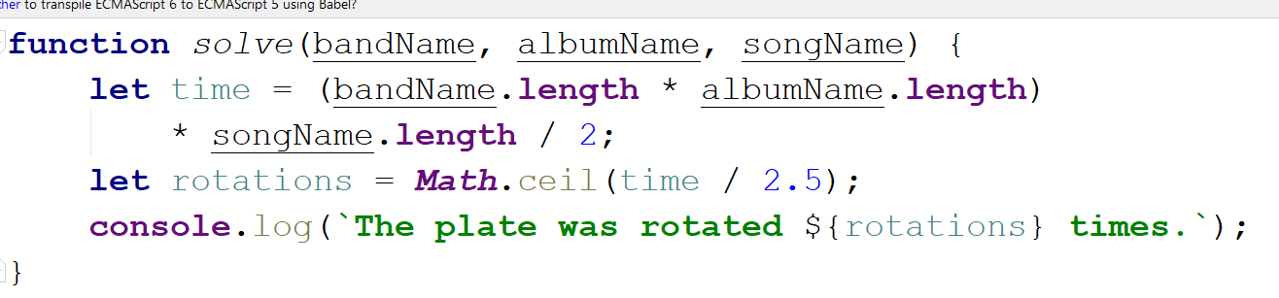

## Fuel Money

Write a **function** which **calculates** how much **money** for fuel will be needed to drive а bus from one place to another.Consider the following:

* Calculate **the fuel** by knowing that **an empty bus** can pass **100** **km** with **7L** diesel.
* **One person** in that bus excluding the driver increases fuel consumption by **100 milliliters**.
* The **money** is calculated by **multiplying** the **fuel price** with the **needed fuel** for the trip.

As **input** you will receive **3 parameters (**the **distance** the bus must travel**,** the **passengers** in it and the **price** for **1 liter of diesel)**

As **output** you should print this message: **"Needed money for that trip is {neededMoney} lv"**

### Examples

|  |  |
| --- | --- |
| **Input** | **Output** |
| 260, 9, 2.49 | Needed money for that trip is 47.559lv. |
| 90, 14, 2.88 | Needed money for that trip is 22.176lv. |

### Hints

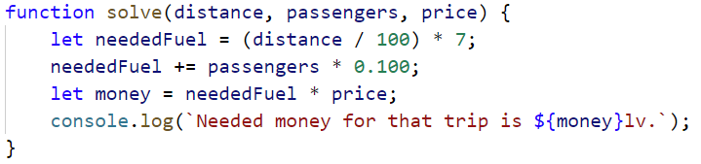

## Centuries to Minutes

Write program to receive a **number** of **centuries** and convert it to **years**, **days**, **hours** and **minutes**.

**Examples**

|  |  |
| --- | --- |
| **Input** | **Output** |
| 1 |  |
| 5 | 5 centuries = 500 years = 182621 days = 4382904 hours = 262974240 minutes |

**Hint**

* Assume that a year has 365.2422 days at average ([the Tropical year](https://en.wikipedia.org/wiki/Tropical_year)).

**Solution**

You might help yourself with the code below:

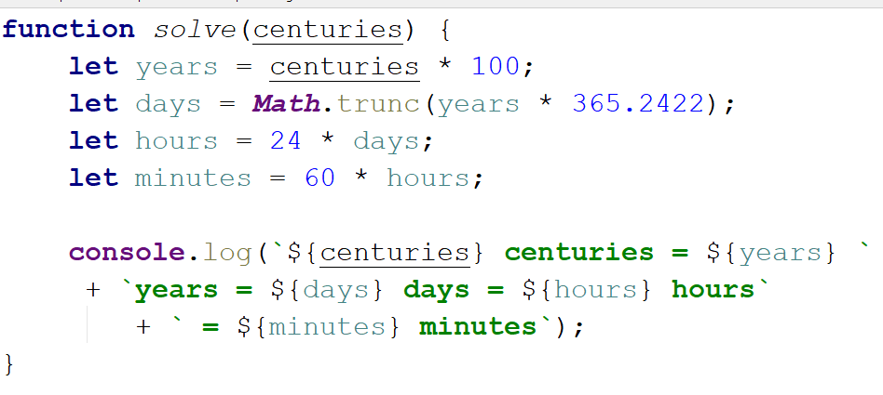

1. **Special Numbers**

Write a program to receive a number **n** and for all numbers in the range **1…n** print the number and if it is special or not (**True** / **False**).

A **number** is **special** when its **sum of digits is 5, 7 or 11**.

**Examples**

|  |  |
| --- | --- |
| **Input** | **Output** |
| 15 | 1 -> False  2 -> False  3 -> False  4 -> False  5 -> True  6 -> False  7 -> True  8 -> False  9 -> False  10 -> False  11 -> False  12 -> False  13 -> False  14 -> True  15 -> False |

**Hints**

To calculate the sum of digits of given number **num**, you might repeat the following: sum the last digit (**num** **%** **10**) and remove it (**sum** **=** **sum** **/** **10**) until **num** reaches **0**. Use **parseInt()** while dividing to get only integer numbers.

1. **Triples of Latin Letters**

Write a program to receive a **number** **n** and print all **triples** of the first **n small Latin letters**, ordered alphabetically:

**Examples**

|  |  |
| --- | --- |
| **Input** | **Output** |
| 3 | aaa  aab  aac  aba  abb  abc  aca  acb  acc  baa  bab  bac  bba  bbb  bbc  bca  bcb  bcc  caa  cab  cac  cba  cbb  cbc  cca  ccb  ccc |

**Hints**

Perform 3 nested loops from **0** to **n**. For each number **num** print its corresponding Latin letter as follows:



The function **String.fromCharCode()** gets the value in **decimal** and transforms it to a character from the **ASCII table**.